I Think, Therefore I Teach: Evolutions in Early Modern Education

International Conference
University of Leuven (Belgium)
26-27 October 2017

Call for Papers

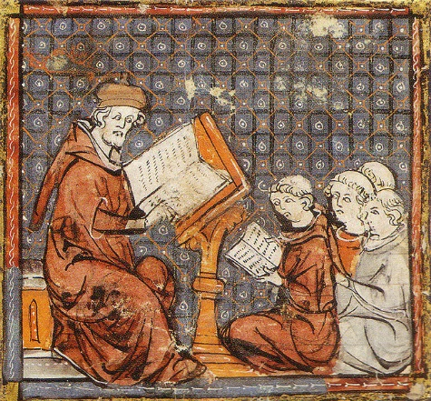
Universities in the Early Modern age saw a great deal of evolution in their institution, their methods, and their curricula. From the philosophical and scientific activity of their professors to the didactical methods used, much still remains to be investigated before we can fully comprehend the place of these institutions in Western culture.
The history of universities has, of course, enjoyed considerable scholarly attention, but the research undertaken thus far often leaves open large blind spots. For instance, historians of universities often do not go further than an analysis of the institutional documents, e.g. official regulations, lesson time tables, the documents detailing curriculum reforms… and often fail to examine the source material itself (i.e. handbooks, student notes…).
When we look at historians of the specific fields treated in Early Modern universities, we find similar shortcomings. Historians of logic are rarely interested in the period after 1400, or 1500 at the latest. Even if the 17th or 18th centuries are taken into account, the impact of, say, the rise of Spanish scholastic or Jansenist logic on university teaching practically never takes centre stage. The available literature all too often takes an analytical perspective, i.e. an attempt at formalizing logical theories or at detailing developments in the field of logic as such, without highlighting its unique position in the university curriculum.
Historians of the natural philosophy, then, are mainly interested in the emergence of the Modern scientific world view, i.e. in the emergence of Cartesian and Newtonian physics, or Copernican and Galilean astronomical theories. The impact of these and other contemporary physical doctrines on university teaching has not been documented systematically, however.

The aim of the present conference, which will be held in Leuven in October 2017 (exact date to be confirmed), is to enhance our understanding of the way in which evolutions on the European scene were adopted, refuted, or merely ignored in university teaching of the time. Important focal points are the paradigm shifts in the didactical methods and the curricula, e.g. from late scholasticism to humanism, from Spanish scholasticism to Cartesianism, the influence of Jansenism and Port-Royal. Geographically, the conference will focus on European teaching, and chronologically, on the period from 1500-1800, being a wildly interesting but vastly understudied time segment.
Attention will be paid mainly to the teaching of logic and natural philosophy, since both disciplines – more so than e.g. the teaching of civil and canon law, evolved in tandem with the philosophical and scientific developments on the larger scale of European society.
Abstracts of c. 250 words and a brief CV (one page max.) may be sent to steven.coesemans@kuleuven.be for review until June 15, 2017. Further questions may be submitted to the same email address. Early career researchers are especially encouraged to submit a proposal for a paper presentation. Notification of acceptance will be sent via email by July 15, 2017.
For the final version of the papers, publications in printed proceedings is planned. Specifics concerning accommodation etc. will follow.

Keynote Speakers:
E.J. Ashworth (University of Waterloo, Canada), L. Brockliss (University of Oxford, UK), Roger Ariew (University of South Florida, USA).

