CALL FOR PAPERS – DEADLINE APPROACHING
Hamlet in Wittenberg: Civic and Princely Education in Early Modern Europe

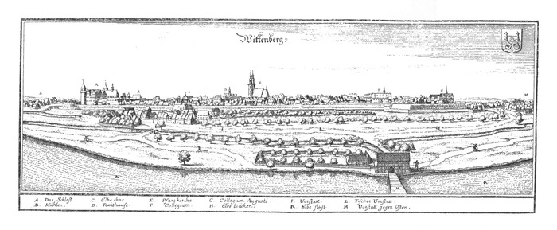

A workshop with the title "Hamlet in Wittenberg: Civic and Princely Education in Early Modern Europe" is organised by the Institute of Philosophy of the Hungarian Academy of Sciences.
The aim of the conference is to gain an overview of the state of the arts and recent tendencies in the research field of early modern - princely and civic - political education.
Keynote speakers:
James Hankins (Harvard University),
Jan Waszink (Leiden University),
Tibor Fabinyi (Károli Gáspár University).

Date of the conference: 28-29. September, 2018.
To participate please send by 15 May a title and an abstract of 3-500 words to fi.titkarsag@btk.mta.hu
Further details: https://hamlet-in-wittenberg.webnode.hu/call-for-papers/
Organisers: Ferenc Hörcher and Ádám Smrcz

